No. | Test Case | Output | Remarks
1 | Valid User Login | Career Centre Staff:  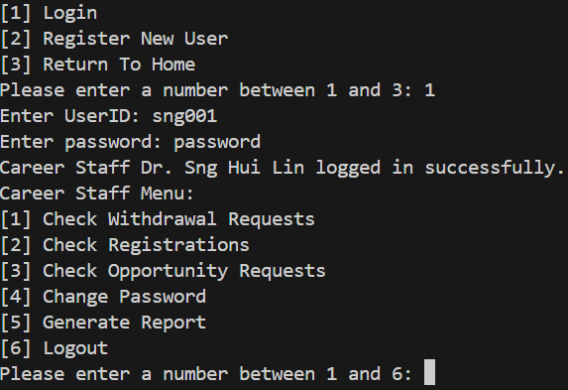  Student:  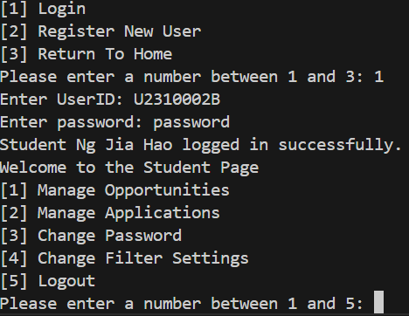  Company Representative:  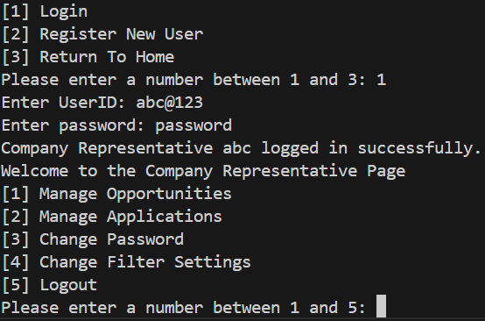
2 | Invalid ID | Correct ID: sng001  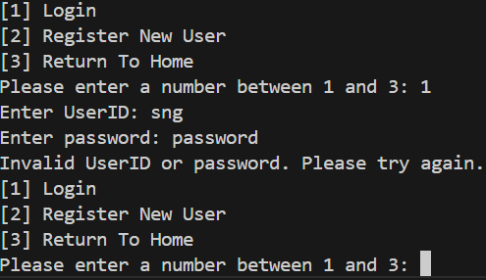 | For security reasons, as per realism, test cases 2 and 3 would not be discrete cases.  Merely a design choice.  The career centre staff pre-password change was used as an example. Refer to test case 1.
3 | Incorrect Password | Correct Password: password  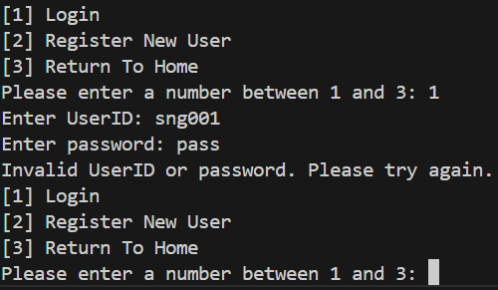
4 | Password Change Functionality | Carrer Centre Staff:  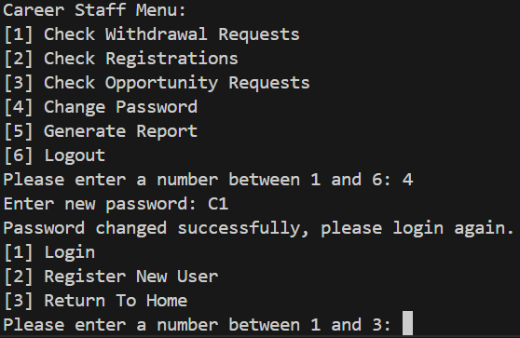  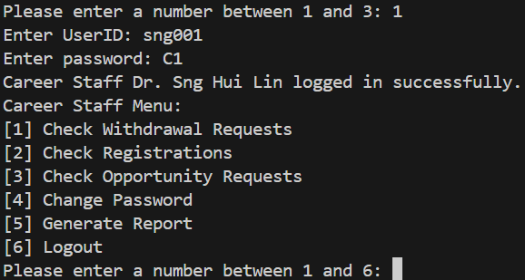  Student:  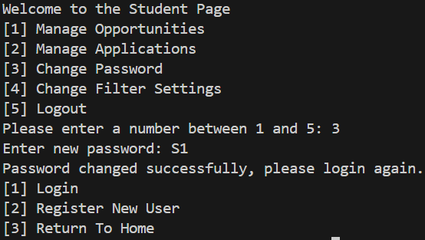  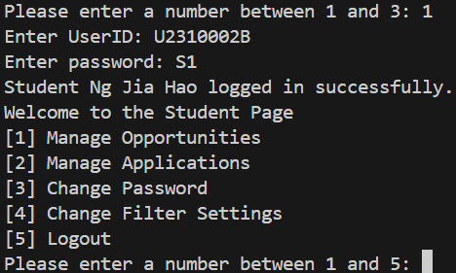  Company Representative:  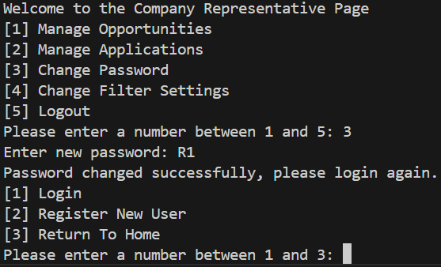  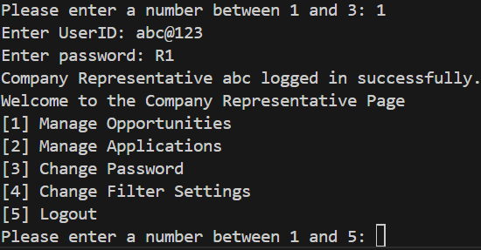 | Refer to test case 1 for pre-password change outputs.
5 | Company Representative Account Creation | Account creation:  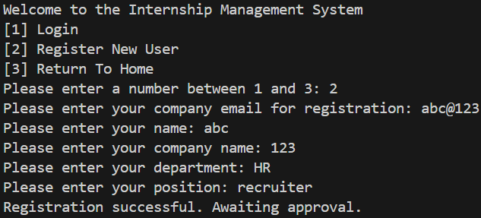  Before approval by Career Centre Staff:  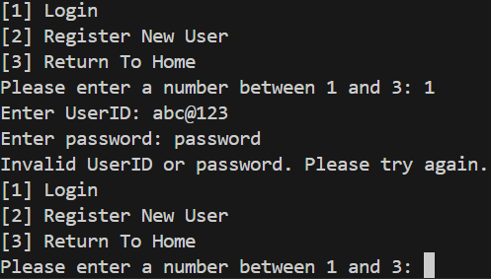  After approval by Career Centre Staff:    Rejected account creation:  (The rejection)  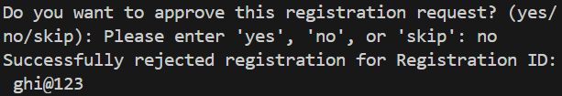  (Attempt to login)  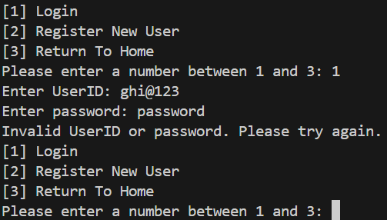
6 | Internship Opportunity Visibility (Student) | Visibility (student has not applied):  (Student particulars)  (visibility on)  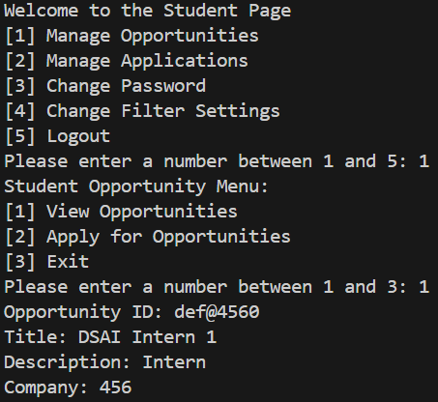  (visibility off)  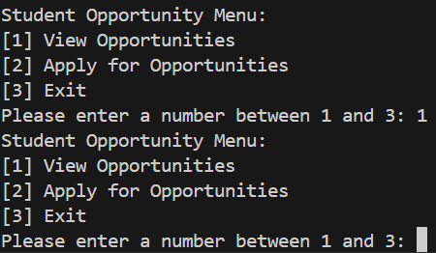 | Visibility toggle is controlled by the company representative.  Refer to test case 18 for the flow of visibility.  Refer to test case 17 which shows that the internship opportunity (def@4561) was rejected.  Correctly, this student cannot see the rejected internship opportunity, only the approved one.  Refer to test case 7 for visibility based on user profile.
7 | Internship Application Eligibility (Student) | Student particulars:  Opportunity details:  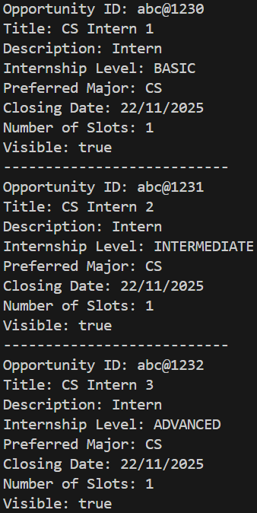  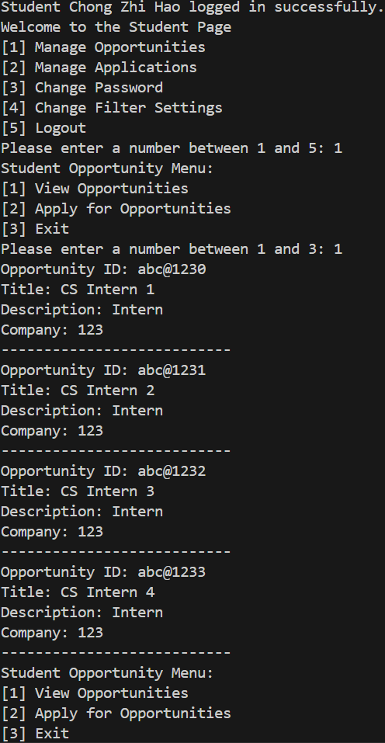    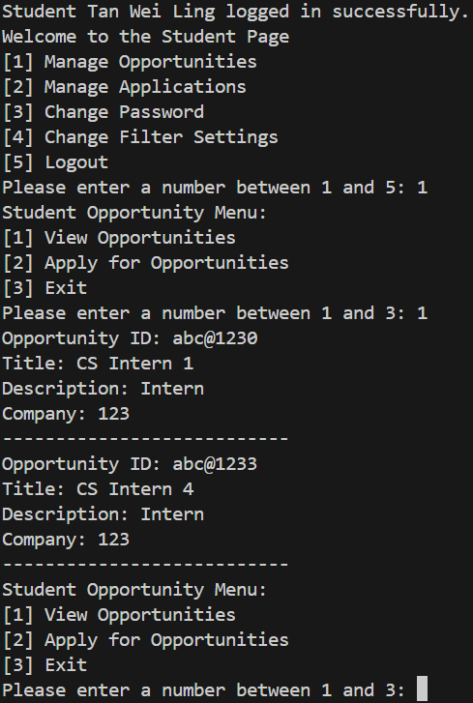    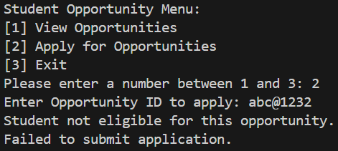  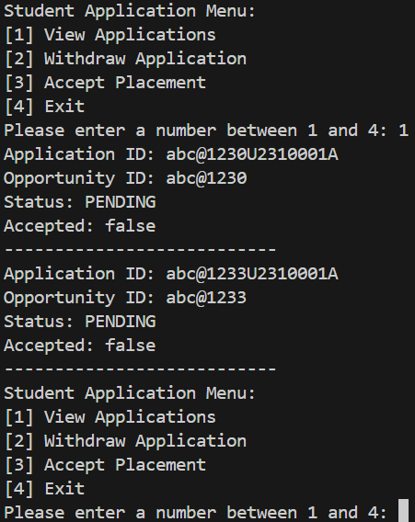   | For eligibility based on visibility, refer to test case 6.  Different students were used in test case 6.  Correctly, the internship opportunity for DSAI (def@4560) is not visible here.  Moreover, this year 4 student can see the intermediate and advanced internship opportunities.  Correctly, the internship opportunity for DSAI (def@4560) is not visible here.  Moreover, this year 1 student cannot see the intermediate and advanced internship opportunities.  As an example, the year 1 student cannot apply for the advanced internship opportunity, even if they know it exists.
8 | Viewing Application Status after Visibility is toggled off  (Student) | Student particulars:  Visibility:  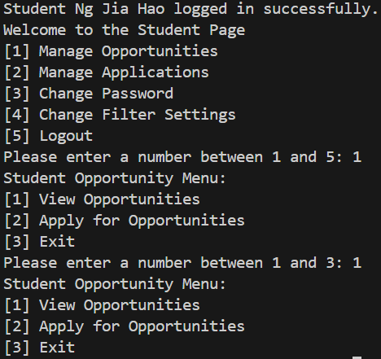  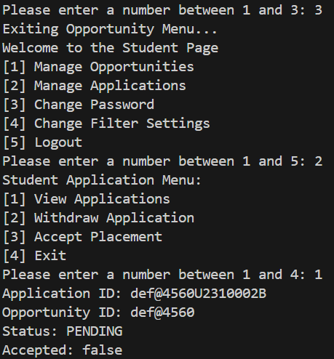 | Refer to test case 18 for the flow of visibility.  Currently, visibility is set to false.
9 | Single Internship Placement Acceptance per Student | Before acceptance:  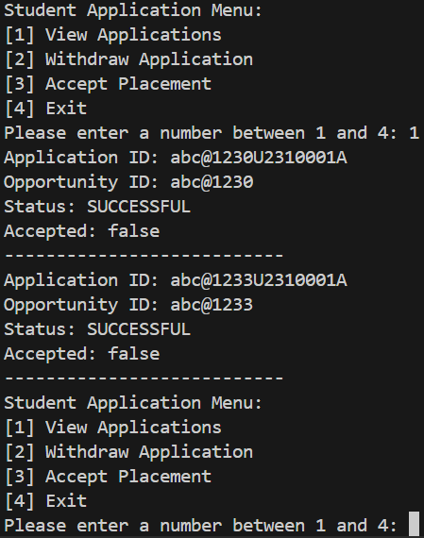  After acceptance:  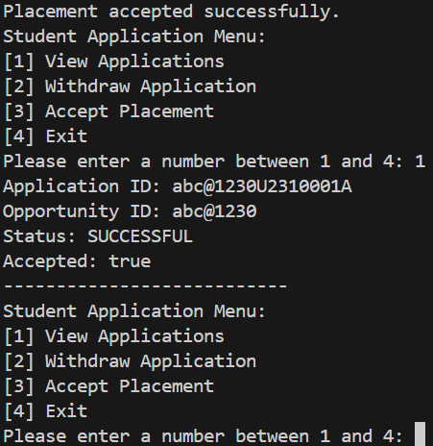
10 | Company Representative Internship Opportunity Creation | Maximum internship opportunities reached; handling of invalid data (here the date):  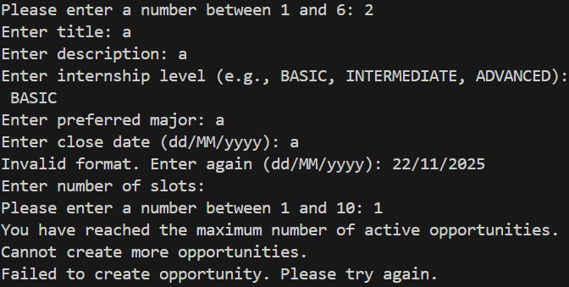 | Refer to test case 16 for successful internship opportunity creation.
11 | Internship Opportunity Approval Status (Company Representative) | Visibility turned on:  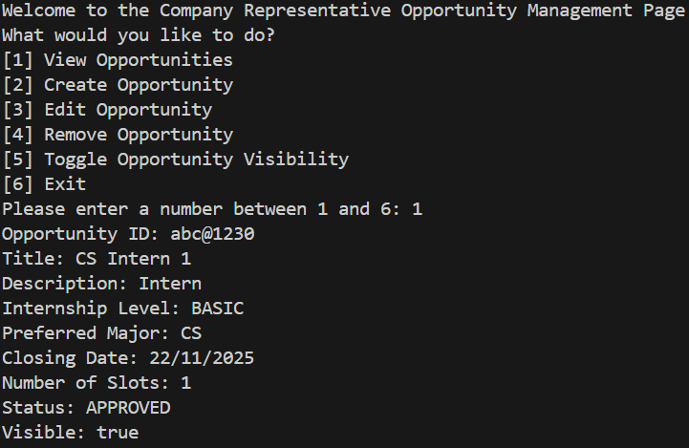  Visibility turned off:  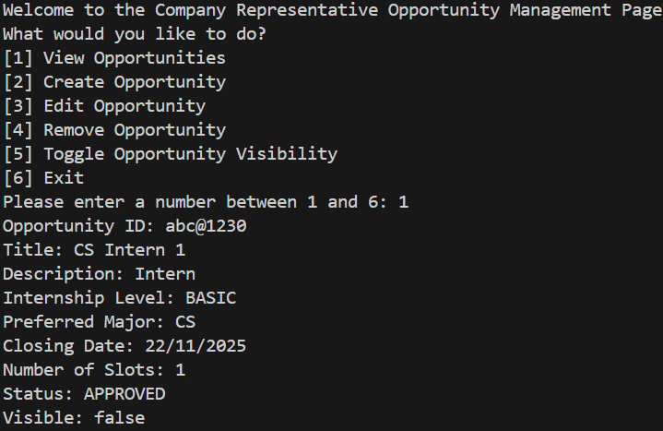
12 | Internship Detail Access (Company Representative)
13 | Restriction on Editing Approved Opportunities (Company Representative) | Before approval by Career Centre Staff:  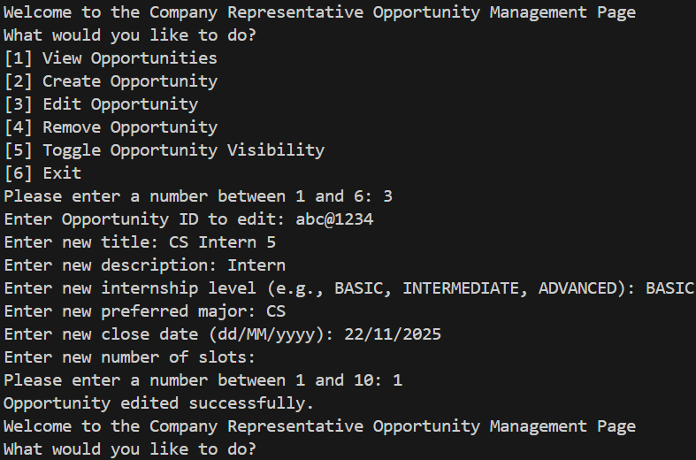  After approval by Career Centre Staff:  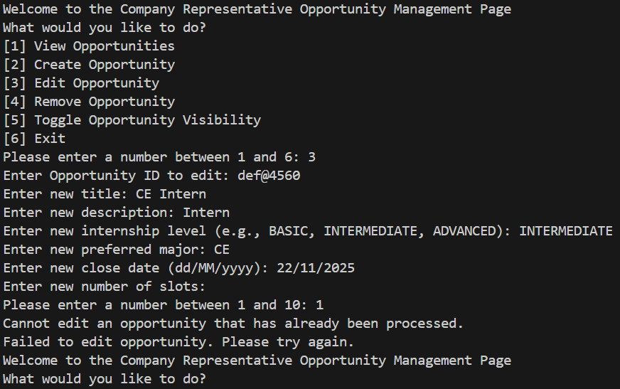
14 | Student Application Management and Placement Confirmation | Retrieving correct student application:  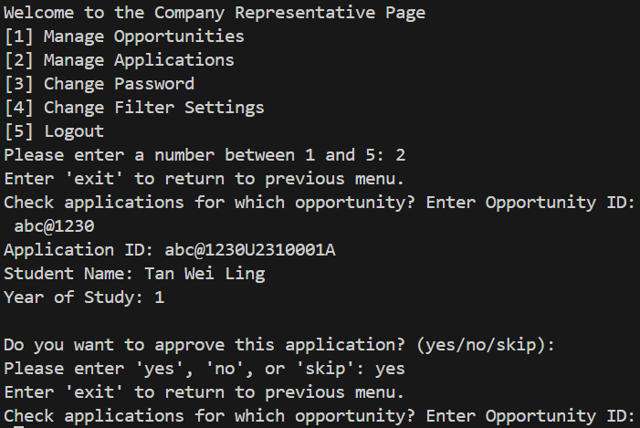  Student cannot apply once slots filled:  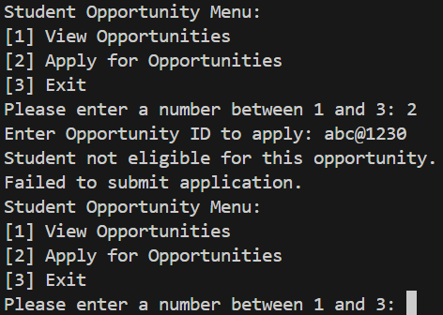   | The vacancy for the opportunity was set to one.
15 | Internship Placement Confirmation Status Update |  | Refer to test case 9 for pre-acceptance outputs.
16 | Create, Edit and Delete Internship Opportunity Listings | Creation:  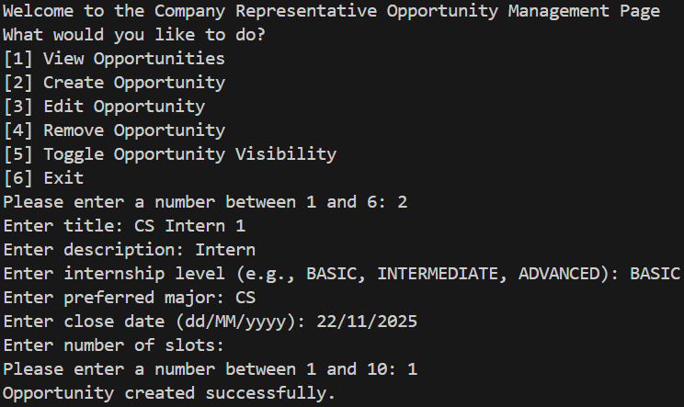  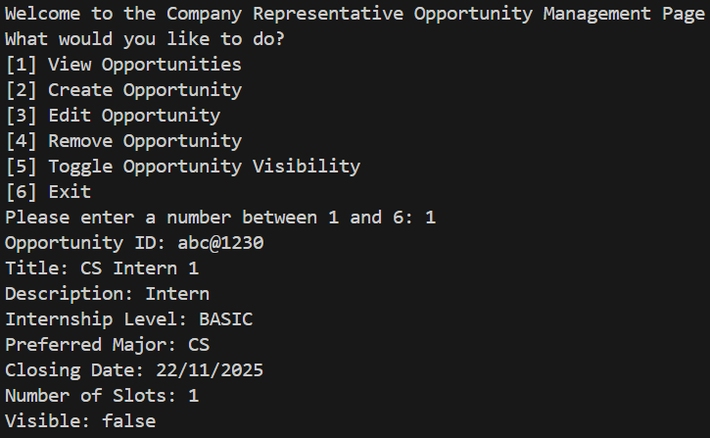  Delete:  (Not from representative’s company)  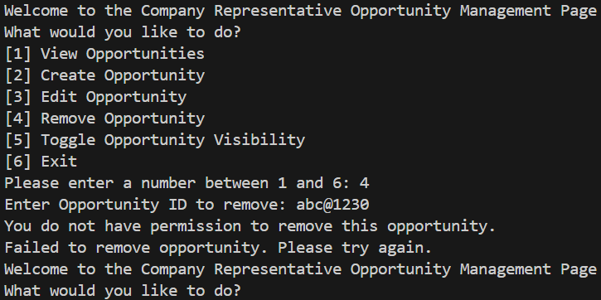  (From representative’s company)  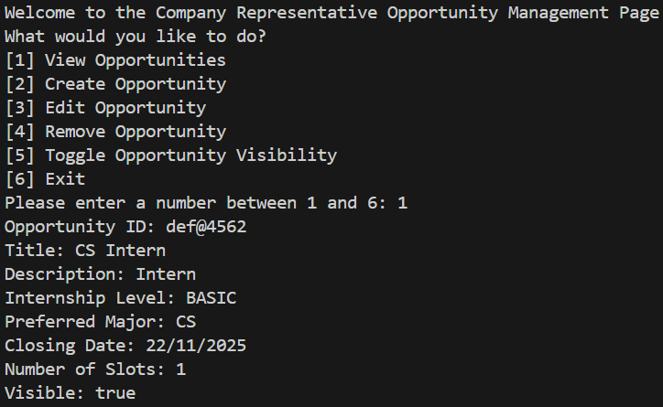  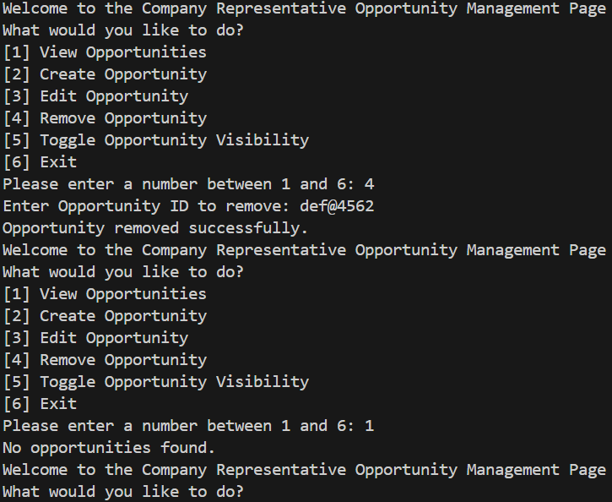 | Refer to test case 10 for restrictions of internship opportunity creation.  Refer to case 13 for editing of internship opportunities.
17 | Career Centre Staff Internship Opportunity Approval | Approved internship opportunity:  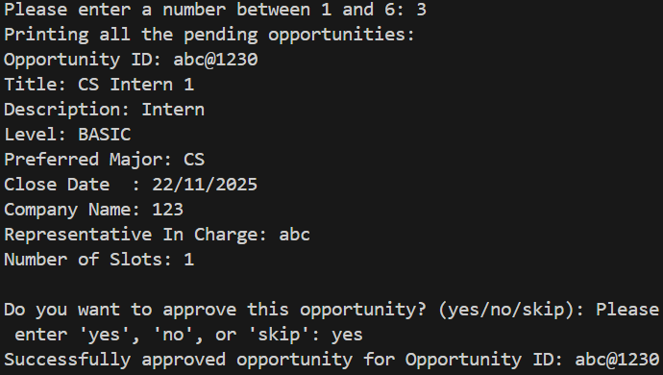  Rejected internship opportunity:  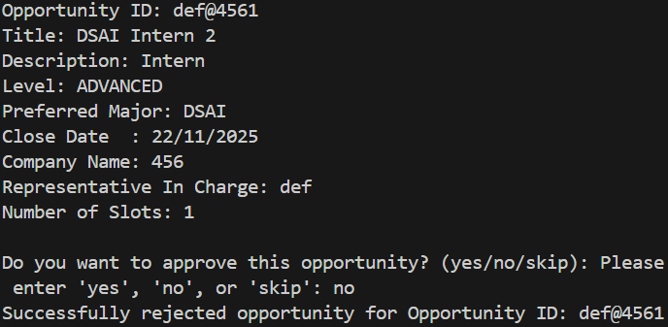 | Refer to test case 11 and 12 for the viewpoint of the company representative.
18 | Toggle Internship Opportunity Visibility (Company Representative) | 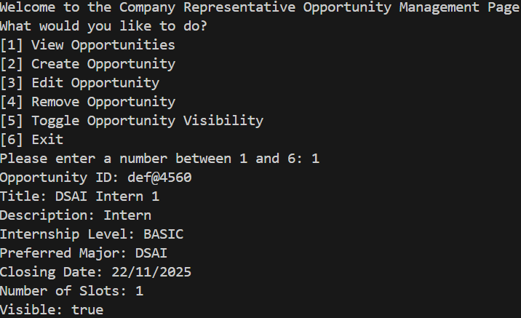  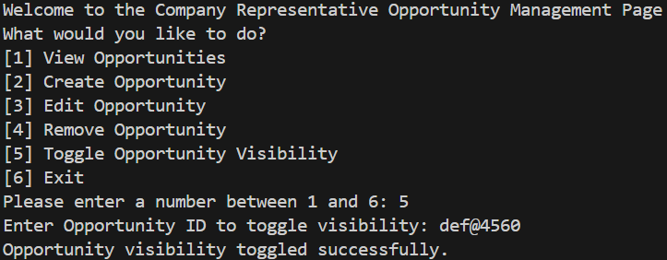  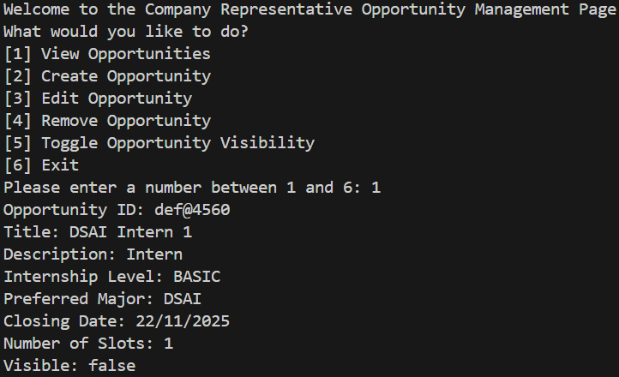 | Refer to test case 6 for the viewpoint of the student.  The flow of visibility in this test case is used for test cases 6 and 8.
19 | Career Centre Staff Internship Opportunity Management | Withdrawal before acceptance:  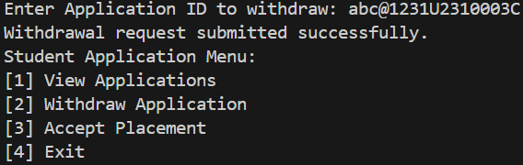  Withdrawal after acceptance:  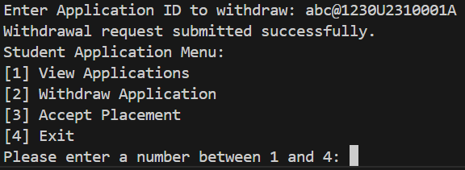  Withdrawal management:  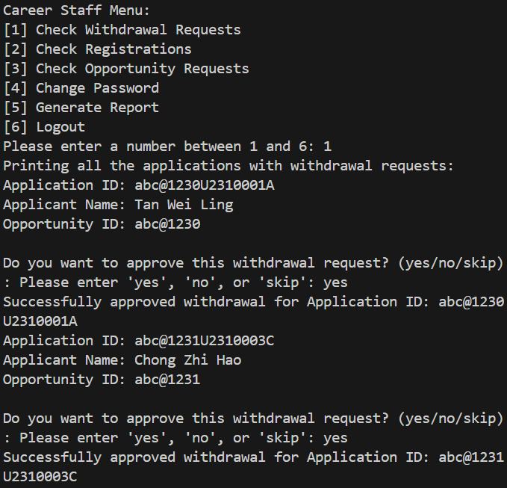  Another student attempts to apply when the opportunity is filled:      Another student attempts to apply when a vacancy opens:  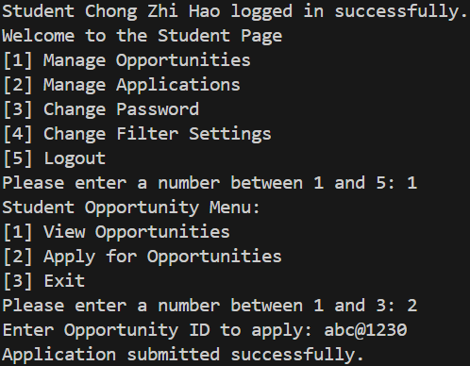 | The vacancy for the opportunity was set to one.  Refer to test case 9 which shows that the internship opportunity was accepted.  The opened vacancy in this test case is consequence of a student who has accepted the internship but withdraws his acceptance.
20 | Generate and Filter Internship Opportunities | Unfiltered:  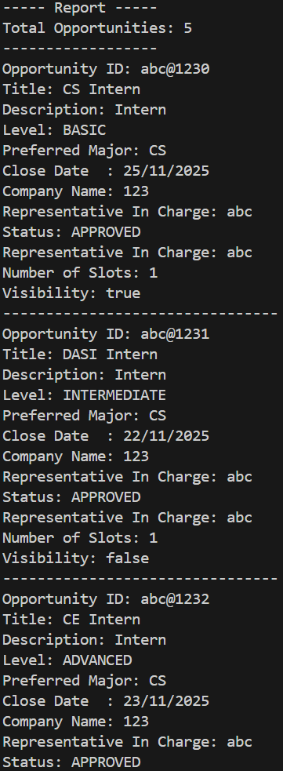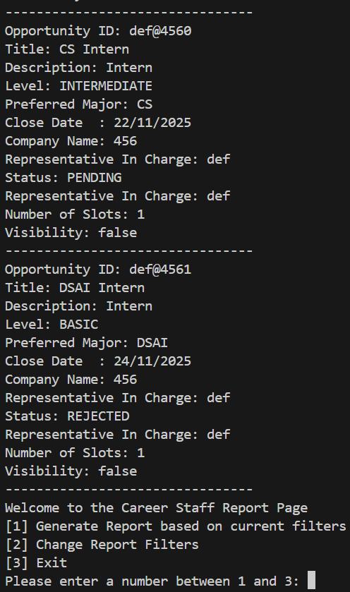  Internship Level (Eg. Basic):  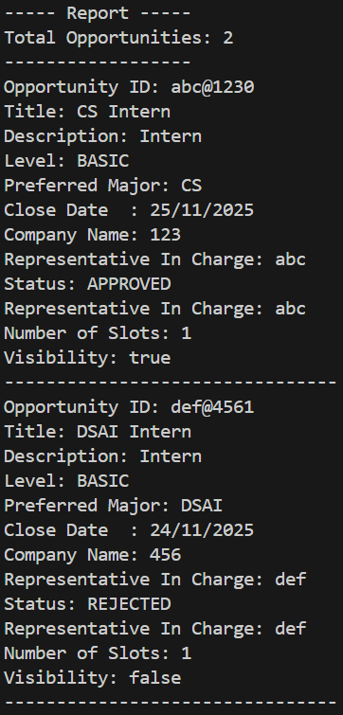  Major (Eg. DSAI):  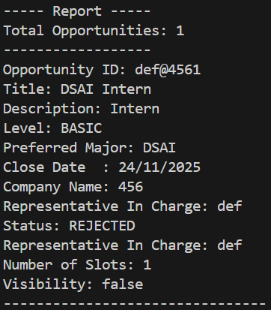  Status (Eg. Pending):  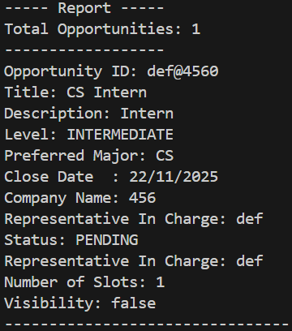  Visibility (Eg. true):  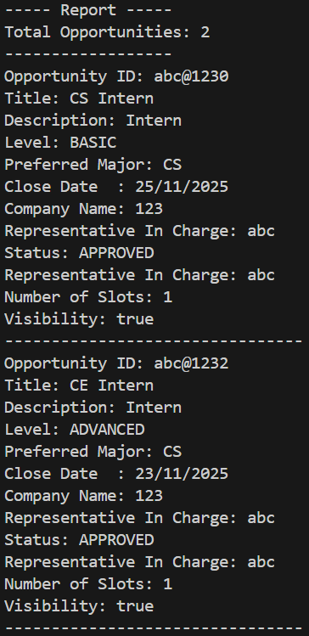  Closing Date (Eg. 22/11/2025):  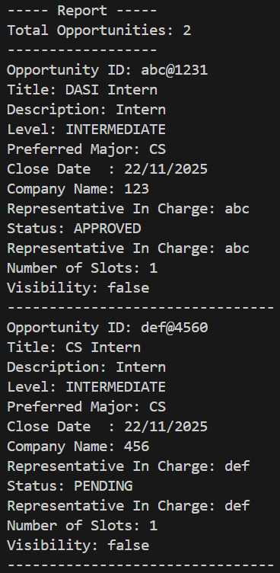  Company Name (Eg. 456):  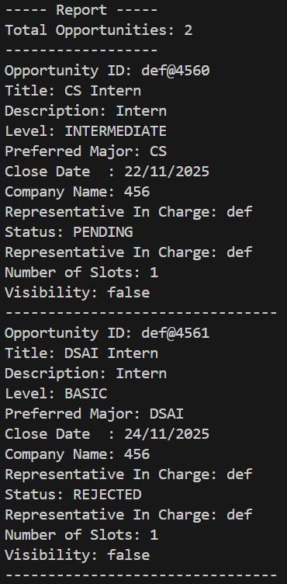  Combination (Eg. Basic and Approved):  